Lumos Logic HRMS
Sanghavi Association
Client Delivery Document
Prepared by: Lumos Logic
Date: July 2026
Version: 1.0

1. System Overview
Sanghavi Association has been provisioned on the Lumos Logic HRMS platform — a dedicated, isolated deployment with full biometric attendance integration via your existing ZKTeco devices.

What Has Been Delivered
Module | Status
HR Admin Dashboard | Live
Employee Management | Live
Leave Management | Live
Attendance (Manual + Biometric) | Live
Biometric Device Management | Live
Departments & Designations | Live
Holidays & Events | Live
Leave Policies | Live
Announcements | Live
Attendance Regularization | Live
Employee Documents | Live
Branches Management | Live
Reports & Analytics | Live
Payroll (Basic) | Live
Expenses | Live
Assets | Live
Performance Management | Live
Onboarding Checklists | Live
Exit Management | Live
Extended Employee Profile (Statutory, PF, ESI, UAN, OT) | Live
Biometric ADMS Receiver (ZKTeco Integration) | Live
Employee PIN Mapping (ZKTeco PIN → HRMS Employee) | Live
Raw Punch Log Viewer | Live

2. System Access

Production URL
https://hrms.lumoslogic.com

Login Credentials
Your administrator account will be shared separately via secure message.
Role | Access Level
Root Admin | Full system access — all modules, all settings, all employees
HR Admin | Manage employees, leaves, attendance, announcements, payroll
Employee | Self-service portal — own attendance, leaves, documents, payslips

3. Your ZKTeco Devices — Registered in System
All 7 of your biometric devices are registered in the HRMS. You can view them under Biometric → Devices in the admin dashboard.
# | Serial Number | Device Name | Location | Device IP | Status
1 | BYEL184460001 | Main Area | Main Area | 192.168.10.20 | Online
2 | BYEL194660080 | Dalal | Dalal | 192.168.0.250 | Online
3 | CK5T222360083 | Third Floor | Third Floor | 192.168.10.205 | Online
4 | JJA1241000273 | CG Road | CG Road | 192.168.1.2 | Online
5 | JJA1241900816 | Bapunagar | Bapunagar | 192.168.1.202 | Online
6 | BHXZ193560692 | Insurance Bhuj | Insurance Bhuj | 192.168.0.45 | Offline
7 | JJA1241900721 | Bhuj | Bhuj | 192.168.1.2 | Offline
NOTE Devices marked Offline will show as Online automatically once they are redirected to our server and begin pushing data.

4. Biometric Integration — How It Works
Your ZKTeco devices use the ADMS Push Protocol — meaning the device itself sends attendance punches to a server URL in real time whenever an employee scans. Our system receives these punches and automatically creates attendance records.

Flow Diagram
Employee Scans Finger / Face on ZKTeco Device
│
│ HTTP Push (ADMS Protocol)
▼
Lumos Logic HRMS Server (/iclock/cdata)
│
├── Logs raw punch (audit trail — never deleted)
├── Matches Employee PIN → HRMS Employee record
├── Checks if employee is on approved leave (guard)
└── Creates / Updates attendance record automatically
│
▼
Attendance visible in HR Dashboard
within seconds of the punch

What the System Does Per Punch
- Check-In: First punch of the day → sets Check-In time, marks attendance as Present
- Check-Out: Subsequent punch → sets Check-Out time, calculates work hours
- Leave Guard: If employee has an approved leave that day → punch is silently ignored, leave record is preserved
- Duplicate Protection: ZKTeco sometimes retries failed pushes — our system handles this automatically, no duplicate records are created
- Source Tracking: All biometric-sourced attendance is tagged with a fingerprint indicator so HR can distinguish manual vs. biometric records

5. Device Configuration — Action Required by Your IT Team

Step 1: Get the New Server URL
Configure each ZKTeco device with this ADMS Server URL:
https://hrms.lumoslogic.com
Fallback (direct IP, if domain is unreachable): http://187.127.146.194:3005

Step 2: How to Configure Each Device
On each ZKTeco device or via ZKTeco WDMS software:
- Open ZKTeco WDMS → Go to Device Management
- Select the device
- Go to ADMS or Cloud Server settings
- Update the Server Address field to: hrms.lumoslogic.com
- Set Server Port to: 443 (HTTPS) or 80 (HTTP fallback)
- Save and apply to device
OR — if configuring directly on the device screen:
- On device → Menu → Communication → Cloud Server Settings
- Update the IP and Port
- Confirm / Save
NOTE The path /iclock/cdata is built into the ZKTeco firmware. You only need to update the IP and port — do not change the path.

Step 3: Verify the Connection
After updating each device:
- Log in to HRMS → go to Biometric → Devices
- The device status will change from Offline to Online within 1–2 minutes
- You will see the Last Activity timestamp update in real time

6. Employee PIN Mapping — Required Before Attendance Goes Live
Every ZKTeco punch contains only an Employee PIN (the enrollment number on the device — e.g., 431, 806). The HRMS needs to know which HRMS employee account belongs to each PIN.

What We Need From You
Please provide an export from ZKTeco WDMS containing:
Column | Example
Employee PIN / Enrollment Number | 431
Employee Name | Rajesh Kumar
An Excel or CSV export from the Employee section in WDMS is sufficient.

How It Works in the System
Once we have your employee list, the mapping is done in: HRMS → Biometric → Employee PIN Mapping
Each row maps one ZKTeco PIN to one HRMS employee. After mapping:
- All new punches from that PIN automatically create attendance records for that employee
- All previous punches (that arrived before the mapping was done) are retroactively processed — no attendance data is lost

7. What We Need From You (Checklist)
Please provide the following for go-live:
# | Item | Purpose | Priority
1 | Employee list export from ZKTeco WDMS (PIN + Name) | To create employee accounts and map PINs | Critical
2 | Employee master data (name, designation, department, joining date, contact) | To complete employee profiles | Critical
3 | Leave policy rules (annual leave days, sick leave days, etc.) | To configure leave policies per type | Medium
4 | Holiday list for 2026 | To configure public/company holidays | Medium
5 | Work shift timings (start time, end time, late threshold) | To configure work schedule | Medium
6 | Department list | To create department structure | Medium
NOTE Branches and office locations are already configured in the system (Main Area, Dalal, Third Floor, CG Road, Bapunagar, Bhuj, Insurance Bhuj).

8. What Lumos Logic Will Do After Receiving Above
Step | Action | Timeline
1 | Import employee master data into HRMS | 1 day after data received
2 | Map all ZKTeco PINs to HRMS employees | 1 day after PIN export received
3 | Configure branches, departments, work schedule | 1 day after details received
4 | Configure leave policies and holidays | 1 day after details received
5 | Reprocess all historical punch logs | Same day as PIN mapping done
6 | Confirm all devices are Online and pushing | After your IT updates device settings
7 | Verify end-to-end: punch → attendance record | Within 1 day of first live punch

9. Go-Live Checklist

Our Side (Lumos Logic)
☒ HRMS platform deployed and running
☒ Sanghavi organization created in system
☒ All features enabled (biometric, branches, statutory, leave, payroll, etc.)
☒ ADMS receiver endpoint live at /iclock/cdata
☒ Device heartbeat endpoint live at /iclock/getrequest
☒ Extended employee profile (PF, ESI, UAN, OT, branch fields) ready
☒ All 7 ZKTeco devices registered in system
☒ Domain live — https://hrms.lumoslogic.com active with SSL
☒ All 7 branch locations configured (Main Area, Dalal, Third Floor, CG Road, Bapunagar, Bhuj, Insurance Bhuj)
☒ End-to-end biometric test passed — simulated ZKTeco punch received, attendance auto-created correctly
☐ Employee data imported (pending employee list from client)
☐ ZKTeco PIN → Employee mapping completed (pending PIN export from client)
☐ Leave policies configured (pending policy rules from client)
☐ Work schedule configured (pending shift timings from client)
☐ Holidays configured (pending holiday list from client)

Your Side (Sanghavi IT Team)
☐ Current ADMS server URL noted (before changing)
☐ ADMS server URL updated on all 5 online devices to our server
☐ Bhuj and Insurance Bhuj devices brought online (if applicable)
☐ Confirm all devices show Online status in HRMS dashboard
☐ Test punch: one employee scans → attendance appears in HRMS

10. Parallel Run Period (Recommended)
We recommend running both your old system and the new HRMS simultaneously for 1 week after go-live:
- Employee punches flow to the new HRMS
- HR compares attendance in HRMS vs. old system daily for the first week
- Any discrepancies are investigated and resolved
- After 1 week, if all records match → old system can be decommissioned

11. Biometric Dashboard — Screen Guide
All biometric management is accessible from the left sidebar under the BIOMETRIC section after logging in as Root Admin or HR Admin.

11.1 Biometric Devices
URL: https://hrms.lumoslogic.com/biometric/devices
This screen shows all 7 registered ZKTeco devices. Each card displays:
- Device name and serial number
- Location and branch
- Last seen timestamp — updates in real time every time the device sends a heartbeat
- Online / Offline status — a device turns green (Online) within 1–2 minutes of being pointed to our server; it turns Offline if no heartbeat is received for more than 5 minutes
- View Logs — click to jump directly to punch logs filtered by that device
NOTE Once your IT team updates the ADMS server URL on each device, you will see them flip to Online one by one on this screen.

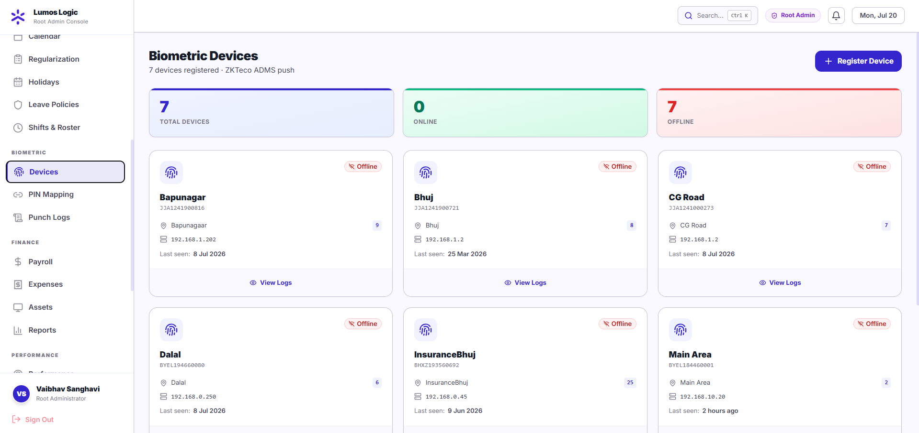

11.2 Employee PIN Mapping
URL: https://hrms.lumoslogic.com/biometric/mapping
This screen links each ZKTeco device PIN (enrollment number) to an employee account in the HRMS. This mapping is what allows the system to know which employee made a punch.
- Each row shows the Device PIN, Employee Name, Department, and Enrollment ID
- + Add Mapping — use to manually map a PIN to an employee
- Reprocess Logs — use after completing all mappings; this retroactively processes any punch logs that arrived before the mapping was set up, so no attendance data is lost
NOTE This screen will be populated once you share the employee PIN export from ZKTeco WDMS.
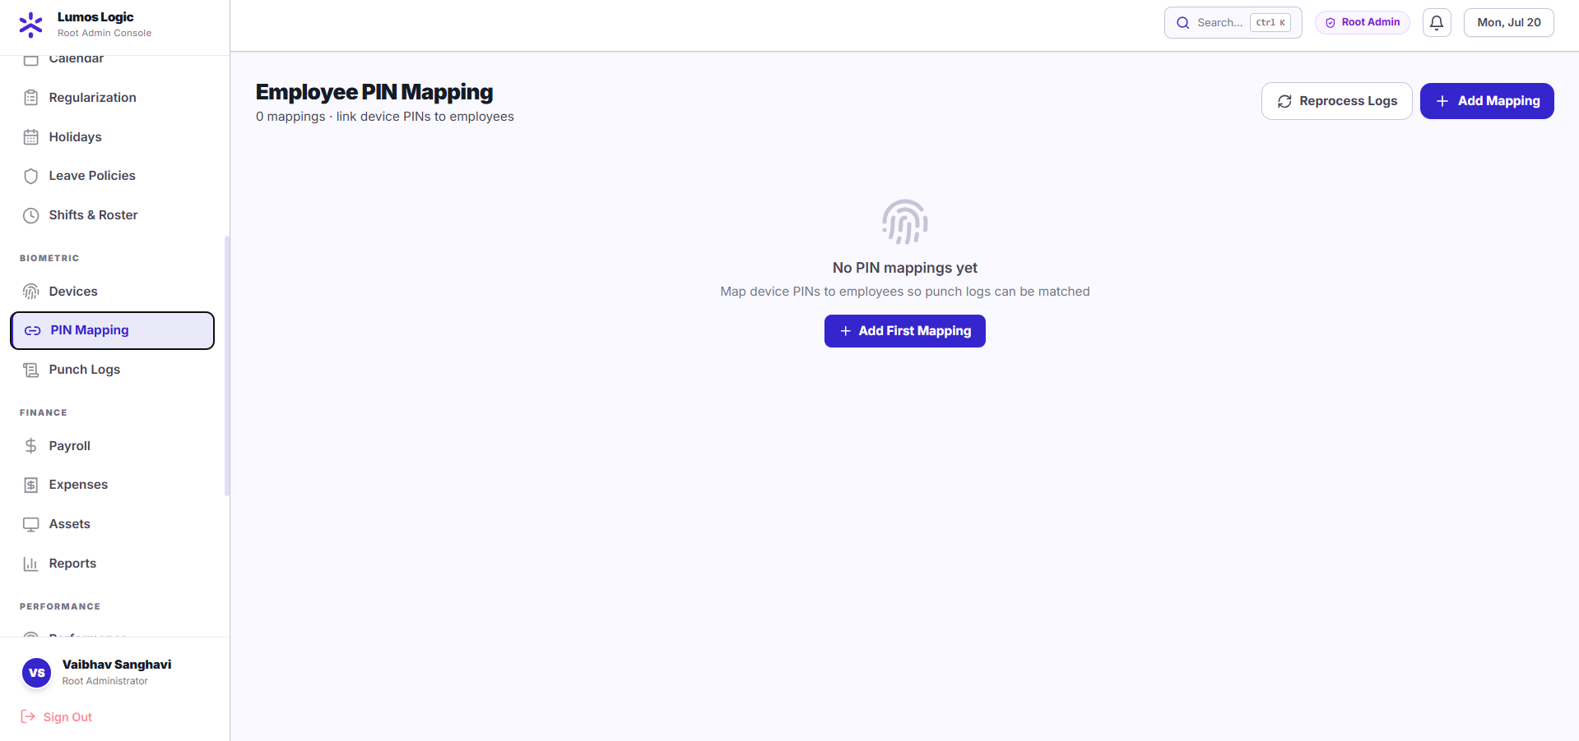
11.3 Punch Logs
URL: https://hrms.lumoslogic.com/biometric/logs
This is the full audit trail of every punch received from any ZKTeco device. Every scan is permanently logged here regardless of whether it was processed into an attendance record.
- Filter by date range, device, employee PIN, or processed status
- Each row shows: punch time, employee PIN, employee name (once mapped), device name, punch type (Check-In / Check-Out), and whether it was processed into attendance
- Processed = Yes means the punch was successfully converted into an attendance record
- Processed = No means the employee PIN is not yet mapped — use Reprocess Logs after mapping to fix this
NOTE This screen is your ground truth for all biometric activity. If there is ever a dispute about an employee's attendance, this log is the permanent record.

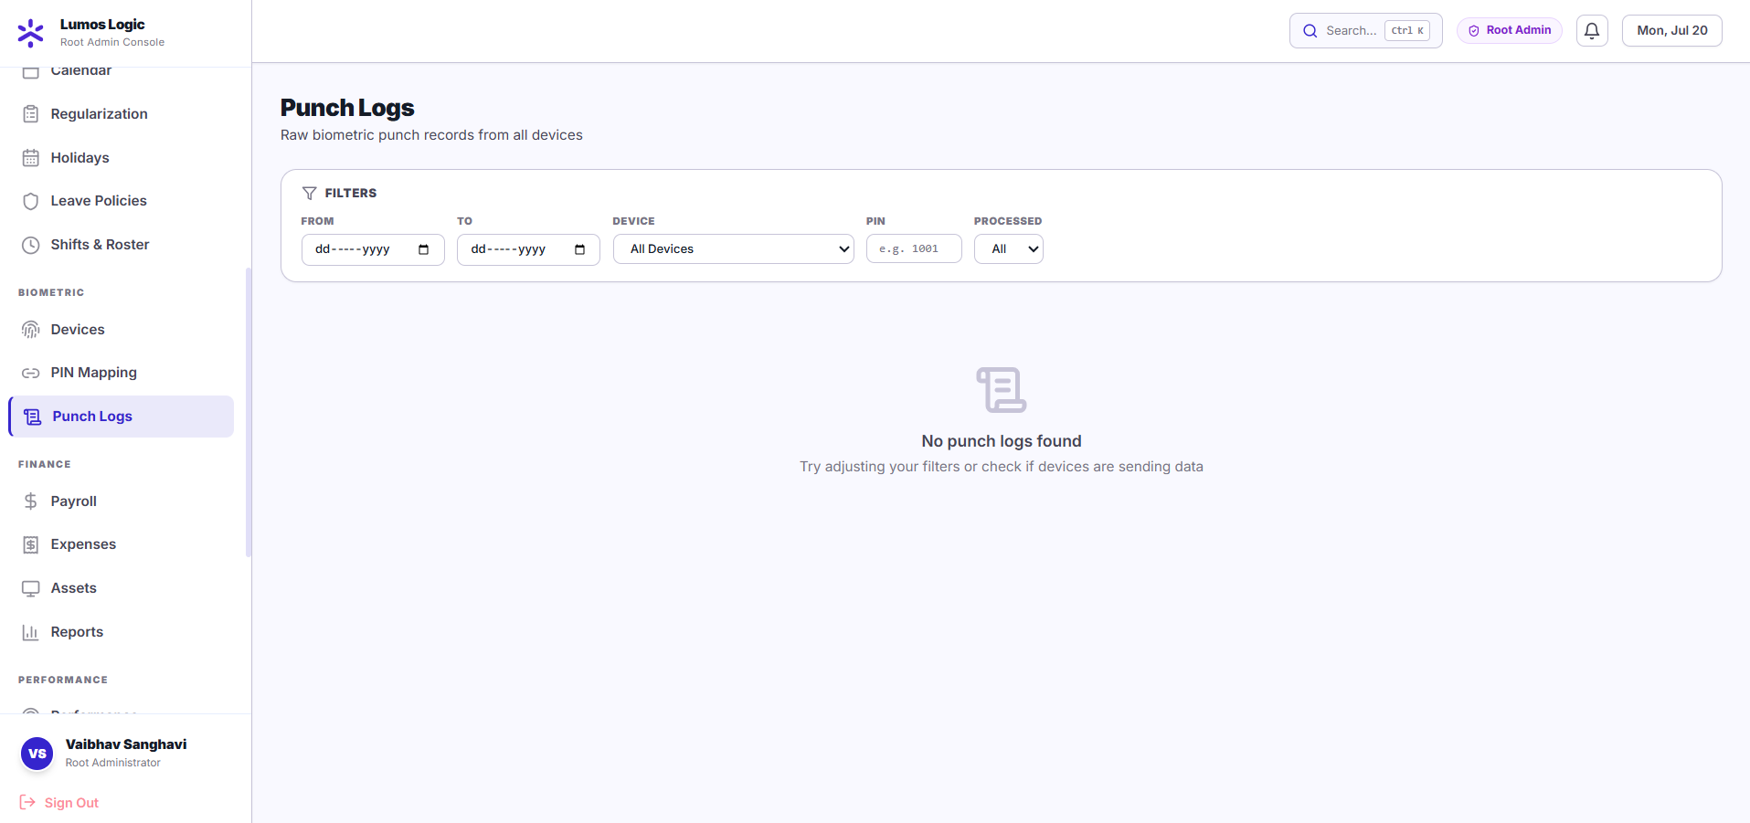

12. Technical Reference

ADMS Endpoints (For IT Reference)
Endpoint | Method | Purpose
/iclock/cdata | POST | Receives attendance punches from ZKTeco devices
/iclock/getrequest | GET | Device heartbeat — keeps device marked as Online
NOTE These endpoints require no authentication — ZKTeco firmware cannot send tokens. They are protected at the network level.

Server Details
Property | Value
Server IP | 187.127.146.194
Port | 3005
Production Domain | https://hrms.lumoslogic.com (Live)
Database | PostgreSQL 15 (isolated for Sanghavi)
Hosting | VPS (Ubuntu 24.04, Docker)
Backup | Daily automated database backup

ZKTeco Punch Type Reference
Punch Type Code | Meaning | HRMS Action
0 | Check-In | Creates attendance record, sets check_in time
1 | Check-Out | Updates attendance record, sets check_out time, calculates work hours
4 | OT Check-In | Logged; OT hours tracked
5 | OT Check-Out | Logged; OT hours calculated

Verify Type Reference
Verify Code | Meaning
1 | Fingerprint
2 | Face Recognition
4 | Card / RFID

13. Frequently Asked Questions
Q: What happens if the internet goes down and a device cannot push punches?
A: ZKTeco devices store punches locally. When connectivity is restored, the device automatically retries and sends all stored punches. Our system handles these late-arriving punches correctly — no data is lost.
Q: What if an employee is on leave but scans at the device?
A: The system checks for approved leave before creating any attendance record. If leave exists for that date, the punch is logged in the audit trail but the leave record is not overwritten.
Q: Can two employees have the same PIN on different devices?
A: No — employee PINs must be unique across the organization. Each PIN maps to exactly one employee. If two locations use the same PIN for different people, the PINs on one location will need to be updated in ZKTeco WDMS.
Q: What if a device sends a duplicate punch (scanned twice by mistake)?
A: Duplicate punches are automatically detected and ignored. The system uses the device serial number + exact punch timestamp + employee PIN as a unique key — no duplicate records are created.
Q: Can we view raw punch logs?
A: Yes — in HRMS go to Biometric → Punch Logs. You can filter by device, employee, date range, and processed status. All punch data is kept permanently for audit purposes.
Q: What happens to old attendance data from our previous system?
A: Historical attendance can be migrated if you provide an export from your old system (CSV or Excel). This is optional — you can also choose to start fresh from the go-live date.
Q: Can employees view their own attendance?
A: Yes — employees can log in to the portal (/portal/home) and see their own attendance, check-in/check-out times, leave balance, payslips, and more.

End of Delivery Document
Lumos Logic
Building smart HR systems.

